Study Guide for Semester 2 Common Assessment
Name: ___________________________________________________ Period: ____________
Concepts to Understand:
- Describe humanism. How was it important during the Renaissance?

- How does the Magna Carta influence rights enjoyed by U.S. citizens today?

- What occurred during the Reformation? Who was responsible for leading the Reformation?

- Describe the caravel. How did it help Europeans reach new lands?

- What are the rights and responsibilities of knights and nobles in the feudal system?

- Describe multiple events that led to the decline of the Roman Empire:

- Describe Hellenistic culture. Who was responsible to spreading it throughout Africa, Asia, and
Europe?

- Define nationalism. How did it lead to World War I breaking out in Europe?

- How did Johann Gutenberg help spread Renaissance ideas throughout Europe?

- Discuss both the positive and negative effects of the Industrial Revolution:

- What social and economic changes did the Black Death bring to Europe?

- Discuss the functions of the European Union:

- Discuss the changes World War II brought to Europe:

- Describe Athenian Democracy. What were the stipulations for being allowed to vote in Athens?

- How did Christianity spread throughout the Roman Empire?

- Explain how BOTH the Roman Republic and Greek/Athenian Democracy influence the United States Government:

17. During the Scientific Revolution, people used _______________ in observations and experiments.

18. The aqueduct was a great achievement for the Romans. List some of things the aqueduct could be used for in ancient Rome:

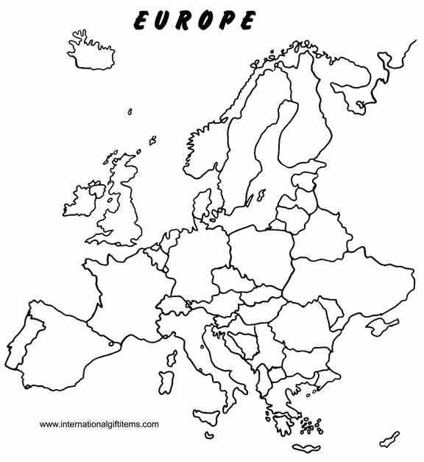

Be able to identify the following nations of Europe on a political map:
- United Kingdom 2. France 3. Spain 4. Portugal 5. Italy
6. Germany 7. Netherlands 8. Switzerland 9. Norway 10. Sweden

Short Answer Prompt #1:
Be able to discuss one of the following topics in paragraph form:
- The Appennine Mountains in Italy
- The Roman Republic
- Events leading to World War I

Short Answer Prompt #2
Be able to discuss the following topic in paragraph form:
- The Great Depression

