Age of Exploration Questions for Canvas Maps and Videos
Name: _______________________________ Period: _________
Map Study: Examine the maps below and answer questions 1-3.
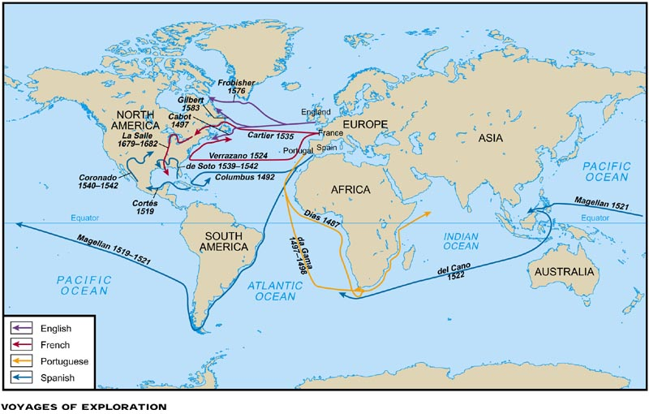

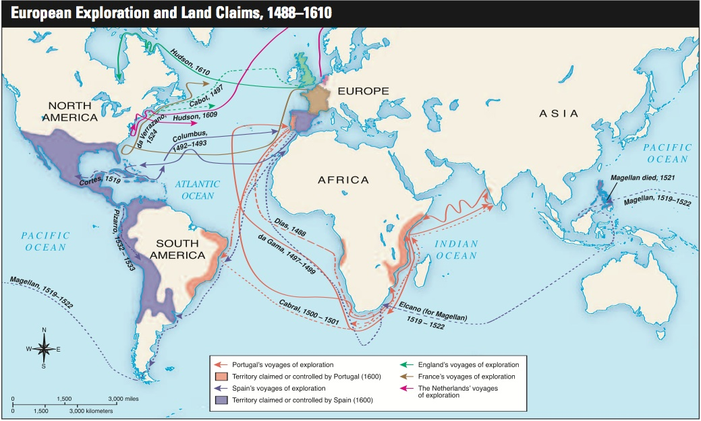

1.) According to the first map, name the only group that did NOT settle in North America:

2.) According to the first map, which groups landed in Canada?

3.) According to the second map, which group successfully landed in India?

Video 1: The Age of Exploration http://youtu.be/neAX1qsrMSs
4.) What were three of the great MOTIVES every nation had when exploring new worlds?

5.) What areas/parts of the world did Portugal conquer?

6.) Who built the caravel? Describe a caravel on the lines provided AND draw it in the box:
_______________________________________________________________________________________________________________________________________________________________________________________________________________________________________________________________

7.) Which explorer/country was first to circumnavigate the world?

8.) What were some of the failures that each European country faced?

9.) Which country had the highest standard of living and literacy rate as a result of exploration?

Video 2: The Portuguese Explorers http://youtu.be/nMT5JIdEsW0
9.) Originally, the Portuguese explored the coast of what continent?

10.) What was Prince Henry’s main goal?

11.) Who was the first explorer to reach the tip of Africa?

12.) What did Vasco da Gama achieve?

Journal Question: In your opinion, how did exploration change Europe and the rest of the world?

