Life in a Medieval Castle: Cold, Dark, and Very Smelly!
Don't be tempted to over-romanticise the unpleasant realities of life in a Medieval castle. To our modern standards of living, most Medieval castles would have been incredibly cold, cramped, totally lacking privacy, and would have been disgustingly smelly (and likely home to more than a fair share of rats!).
Firstly, why were these castles so dark and cold? Well, most Medieval castles were made of stone. Although stone was a perfect material for creating strong, defensive fortifications, Medieval building techniques were basic.
The Keep of Goodrich Castle, built in the 1100s, only had tiny windows - which meant that little light could enter the castle.
This meant that most structures could only support tiny windows - which resulted in dark rooms that were constantly cold, as the thick stone could never be fully warmed by the sun. Late-medieval developments in architecture and gothic castle design did improve on these problems, though, and castles built in the late 1200s began to have larger windows and lighter rooms.
Incredibly, fireplaces weren't invented until the middle of the Medieval period. Until this time, all fires were open fires, which didn't spread heat so effectively (and generated a lot of smoke!). The invention of the fireplace made rooms warmer, as it heated the stones as well as the chamber itself. This made life in a medieval castle much more bearable.
When it came to sanitation, though, things were always truly disgusting. The link between sewerage and disease wasn't made until the c18th, and medieval people remained blissfully ignorant about the health consequences of poor toilet hygiene.
"The stench would have been unbearable - especially in the summer-time"
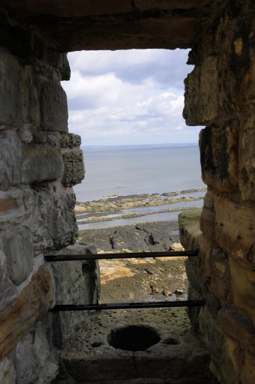
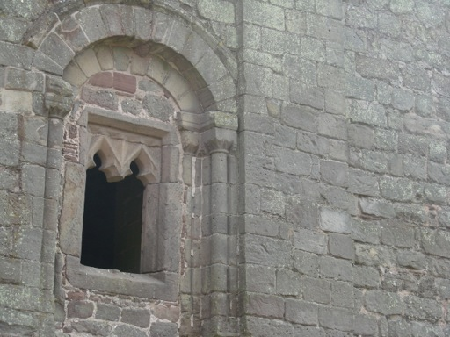
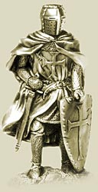

Daily Life of a Knight in the Middle Ages
Life of a Knight
Training for knighthood during medieval times usually began at an early age. Often the prospective knight was sent to live with a relative or lord who had the resources to train the young boy in use of weapons and, most importantly, the skills to handle a horse in combat. A knight-in-training would often serve as a squire (assistant) for an established knight, attending his needs, helping him don his armor, and making ready his horse and weapons.
Once his training was completed and he reached "fighting age" (usually around 16-20 years old), he would ceremoniously become a full-fledged knight. The ceremony became more elaborate as the Middle Ages progressed, until only the richest nobles or a king could afford to "knight" someone.
The new knight now served his liege lord (which may or may not be the king himself), bound to offer military service up to 40 days a year in peace time, more, as needed, in war time. Military duties included castle guard, serving in the lord's "bodyguard", and participating in battle.
Apart from military duties the knight could also participate in administering justice (as part of assizes--a medieval form of our modern juries), manage his estates (which was his prime source of income), and continue to hone his combat skills in tournament.
A Knights Daily Routine:
- The daily life of a Knight started at dawn when Mass would be heard and prayers would be made
- The first meal of the day for the Knight was breakfast
- Knights would engage in weapons practise at the quintain and the pell
- The daily life of the Knights would include discussions on warfare strategy and increasing his knowledge of siege warfare and weapons
- Mid morning prayers and a meal
- As the Medieval period progressed the culture changed becoming more refined and elegant. Knights were expected to understand the rules of Chivalry and courtly love. Time might be spent on dance practise
- In the afternoon the daily life of Knights turned to increasing their skills in horsemanship and would accompany their lord in hunting, hawking or inspecting the estate
- Evening prayer and then supper in the Hall of the Castle or Manor House
- After supper there might be some entertainment - music, dancing, jugglers, acrobats, jesters, etc
- Bedtime prayers

