Name: __________________________

The Colosseum: Ancient Ruin Or Modern Venue?

Directions: Read the article and circle any words that you do not understand. Also, place brackets around the sentence that best describes the main point of each section.
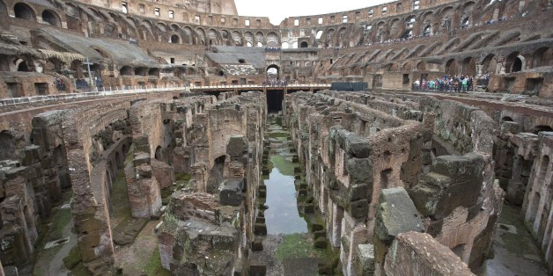
Section 1. Don't expect gladiators to make a latter-day comeback. And soccer has already been ruled out.
But an archaeologist's proposal to return the Colosseum's storied arena to the state it was in when gladiators sparred with lions, has sparked a lively debate over appropriate uses of the monument that symbolizes the glories of ancient Rome.
Critics have fretted that the Colosseum would be turned into a venue for events like rock concerts, viewed as both unbefitting of its stature as an ancient wonder and likely to inflict damage to the structure already weakened by earthquakes, notably in 443 and most recently in the 1700s.
Section 2. Archaeologist Daniele Manacorda of Roma Tre university said his suggestion to replace the arena's long-disappeared floor is aimed at restoring the Colosseum to its original state so visitors can better appreciate its ancient splendor — not turning it into a heavily trafficked concert venue.
"It's the most normal idea in the world," Manacorda said.
The proposal lay dormant, tucked inside the July issue of the specialized Archeo periodical, until Italy's culture minister endorsed it with a tweet Sunday. "It just takes some courage," Dario Franceschini said on Twitter.
Franceschini quickly found himself rebuffing modern-day fantasies, like that of the AC Roma president to play soccer in the arena, while defending Manacorda's proposal.
"Where is it written that you can't protect the value of the Colosseum while also making it more dynamic and useable?" Franceschini said this week. He has placed the idea under study for both costs and feasibility.
Section 3. Visitors entering the Colosseum today can look down into the stadium's labyrinthine belly to the rooms where bears and lions were once caged, and where gladiators prepared for mortal battle. Those utilitarian spaces were covered by the wooden floor of the arena itself during the nearly five centuries that the Colosseum functioned as a center of entertainment, with spectacles including exotic animal hunts and sea-battle re-enactments.
"The absence of the floor is not the result of history that exposed this majestic monument," Manacorda said. "It is the product of archaeological digs in recent centuries."
With the excavations completed, Manacorda said it is time to consider "restoring the monument to the way it always was so that everyone can experience the monument with more ease and clarity." The proposal does not envision restoring the stadium seating.
Section 4. Italians are not in principle against using their ancient monuments as backdrops for entertainment. Verona's Arena, a Roman amphitheater, attracts thousands each summer to its opera series, and performances are set regularly among the Baths of Caracalla in Rome. The Colosseum itself has housed occasional performances, and is visited every year by the pope during the Stations of the Cross.
The Colosseum, however, enjoys a unique status as the most predominant symbol not only of Rome, but of Italy, making sensitive any discussion about altering the status quo.
"It is so important and bulky in its presence, that to transition it into a venue where you perform opera is beneath its dignity," said Giorgio Croci, a structural engineer who is one of Italy's leading experts on the Colosseum. "The image of the Colosseum needs to remain beyond that practical use. It needs to remain an icon, a point of reference with all its history and its past."

Name: ____________________________________________

Comprehension Questions: The Colosseum

1. What does the word ‘fretted’ mean? (Section 1)

a. Thought
b. Wondered
c. Feared
d. Hoped

2. According to the context of the article, what does the word ‘excavations’ mean? (Section 3)

a. Exposes
b. Restores
c. Archaeological digs
d. Monuments

3. Which of the following statements does NOT describe the feelings of this article’s author?

a. The Colosseum needs work to restore its former glory
b. The Colosseum should be restored and used for concerts
c. The Colosseum is an important piece of Rome’s past
d. All of the above

4. In the space below, give textual evidence to support your answer from #3.

5. In the space below, create a new title for this article. It should describe the meaning of the article and it does not need to be a full sentence.

