Name: _____________________________________________ Period: ___________
Ancient Greece Museum Exhibit
At your local museum, you, being an expert on Ancient Greece, have been put in charge of finding exhibits to display at the museum and writing brief descriptions to explain the importance of each. Your descriptions are limited to the size of the textbox provided!
Greek City-States (pg. 304-305)
____________________________________________________________________________________________________________________________________________________________________________________________________________________________
_______________________________________________________
________________________________________________________________________________________________________
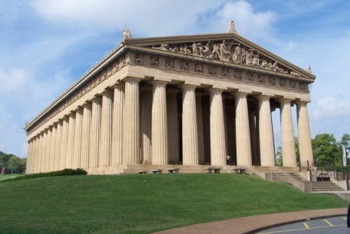

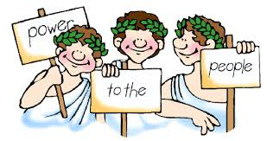
Athenian Democracy (pg. 317)
_______________________________________________________________________________________________________________________________________________________________________________________________________________________________
_______________________________________________________
________________________________________________________
________________________________________________________

