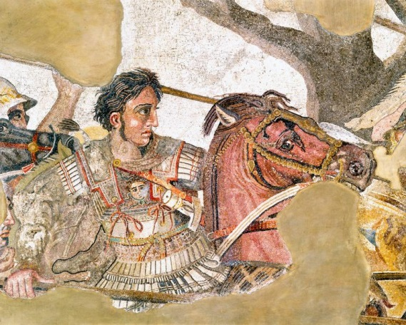

Alexander The Great (p.336-337)

_______________________________________________________________________________________________________________________________________________________________________________________________________________________

____________________________________________________

____________________________________________________

_____________________________________________________

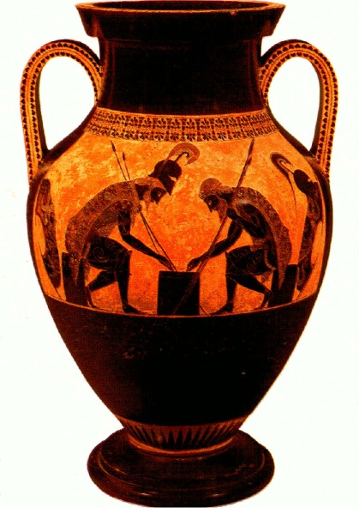

Religion and Art (p.338-341)

_______________________________________________________________________________________________________________________________________________________________________________________________________________________________________________________________

___________________________________________________



Peloponnesian War and Decline of City States (p.332-333)

________________________________________________________________________________________________________________________________________________________________________________________________________________________________________________________________________

_____________________________________________________

____________________________________________________